**BHAVATARINI.M**

**732919ECR018**

**ASSIGNMENT 1**

# MOTION DETECTION USING PIR SENSOR:

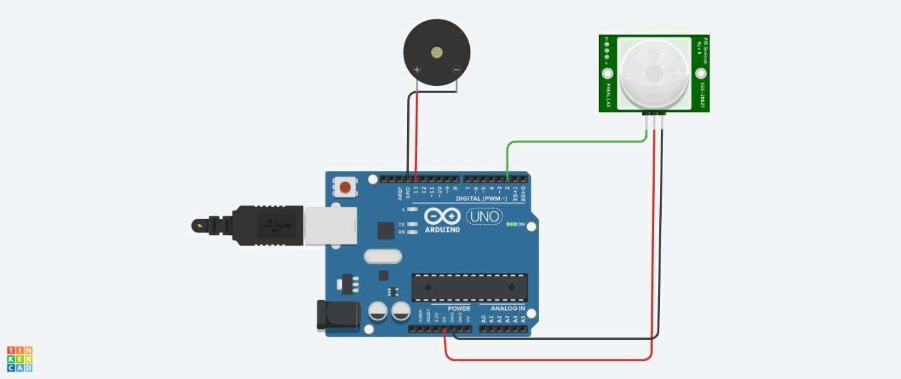

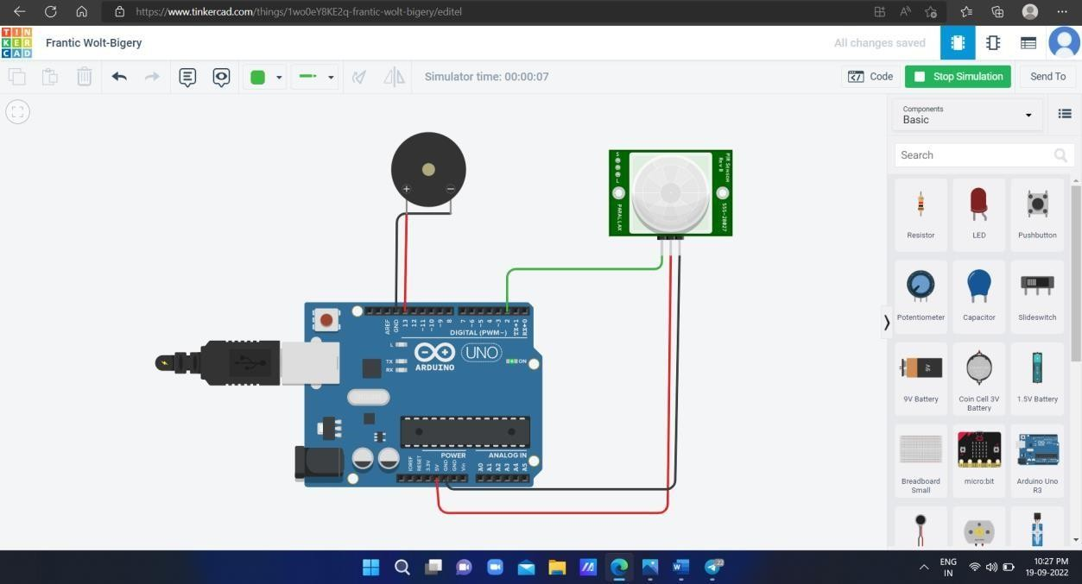

**PROGRAM:**

int sensorState = 0; void setup()

{

pinMode(2, INPUT); pinMode(13, OUTPUT); Serial.begin(9600);

}

void loop()

{

// read the state of the sensor/digital input sensorState = digitalRead(2);

// check if sensor pin is HIGH. if it is, set the

// LED on.

if (sensorState == HIGH) { digitalWrite(13, HIGH);

Serial.println("Sensor activated!");

} else {

digitalWrite(13, LOW);

}

delay(10); // Delay a little bit to improve simulation performance

}

# TEMPERATURE DETECTION USING TEMPERATURE SENSOR

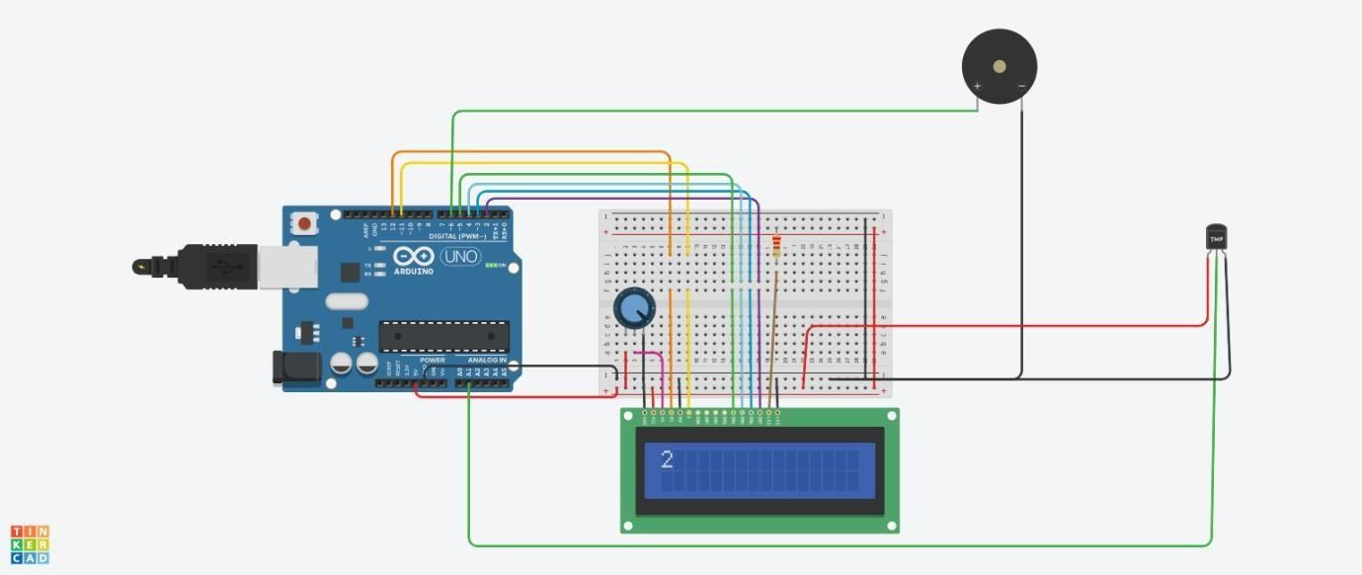

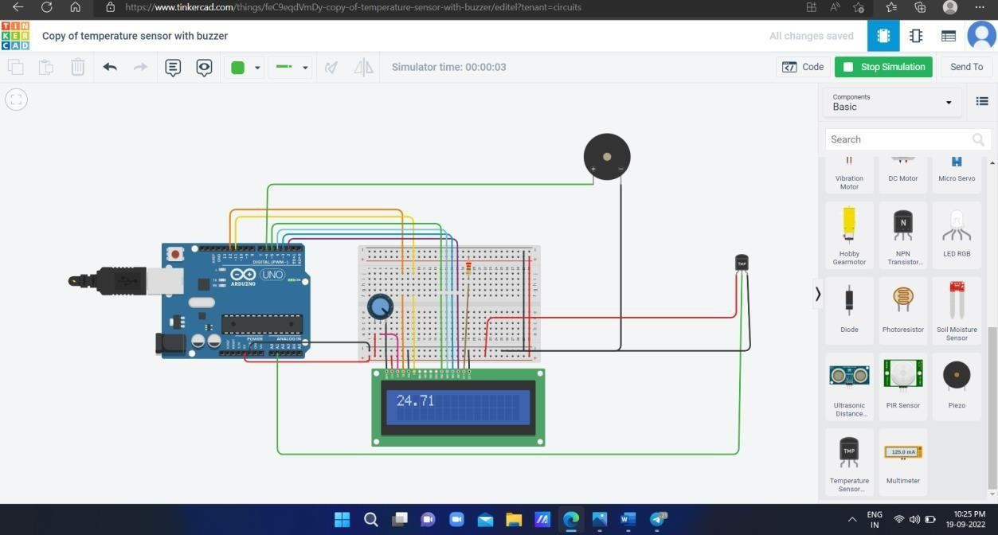

#include <LiquidCrystal.h> LiquidCrystal lcd(12, 11, 5, 4, 3, 2); float a; void setup() {

lcd.begin(16, 2);

pinMode(6,OUTPUT);

}

void loop() { a=analogRead(1); a=a*0.0048828125; a=(a- 0.5)*100;

lcd.clear(); lcd.setCursor(0, 0); lcd.print(a); lcd.print("C"); if(a>60)

{

digitalWrite(6,HIGH);

}

else digitalWrite(6,LOW);

}